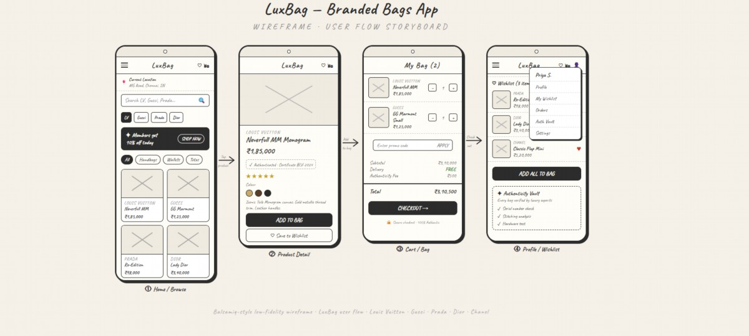

^{EXPERIMENT – 8}
TITEL: APPLICATION APP USING BALSAMIQ

NAME : M.K.Raghavan

ROLL NO : 240701408
TITEL: APPLICATION APP USING BALSAMIQ
LuxBag - Branded Bags App Overview
1. Summary
The LuxBag Mobile App provides users with a place to browse, search, and purchase luxury
branded bags by some of the most popular luxury labels including Louis Vuiton, Gucci,
Prada, Dior, and Chanel. This app is geared towards delivering a luxury shopping experience
through an easy-to-use mobile applicaton containing a wish list management tool, secure
checkout, and product authentcity verifcaton.

2. Goals
The main goals of this applicaton are:
To optmize the shopping experience for users when purchasing luxury bags via the mobile
medium.
To provide users with a selecton of curated luxury brands.
To build user trust through verifcaton of product authentcity.
To improve the user experience through easy navigaton and intuitve design.
3. Intended Users
Fashion lovers
People who buy luxury products
Young professionals and adults
People who buy luxury brands online
4. Applicaton Features
4.1 Home / Browse Page
The inital page displays featured luxury bags, has a search bar to fnd products quickly, has
category flters (all bags, handbags, wallets, totes), and has promotonal banners (discounts).
4.2 Item Detail Page
Each item page has detailed product pages, displaying the price, ratng, and colour choices.
Users can select "add to bag" or "save to wish list".

4.3 Cart / Bag Page
This page shows products selected by the user with the ability to edit select quantty, enter
promotonal codes, and determine shipping cost. This page will also show subtotal, delivery
cost, total, and has a checkout buton.
4.4 User Profle / Wish List Page
Each user will have their profle where they can view items in their wish lists, and the ability
to "add all" to their bag (assumes all items in their wish list) will have access to the user's
order history, profles and setngs, etc.
Conclusion
LuxBag ofers an organized, user-friendly experience that allows consumers to shop easily for
their next luxury bag. The wireframe outlines the main features of the applicaton as well as
how users will navigate through it; therefore, with additonal development and feature
additons, this app has excellent potental to develop into a fully functoning e-commerce
soluton for high-end fashion products.

